**Specifications on Cards:**

Aluminum Cards purchased here:

Using NFC chips purchased here:

Using App called “” to apply link to NFC chips

**How to Create Images for Cards:**

Files can only be made in Adobe Illustrator as an RGB file

Colors for function (all at 255, line 0.001):

Black – Raster (basic image, needing options down below to “pop”)

Blue – Etching (Etching a part of the metal, not all the way through)

Red – Cutting (Cutting through the metal)

Before Alterations:

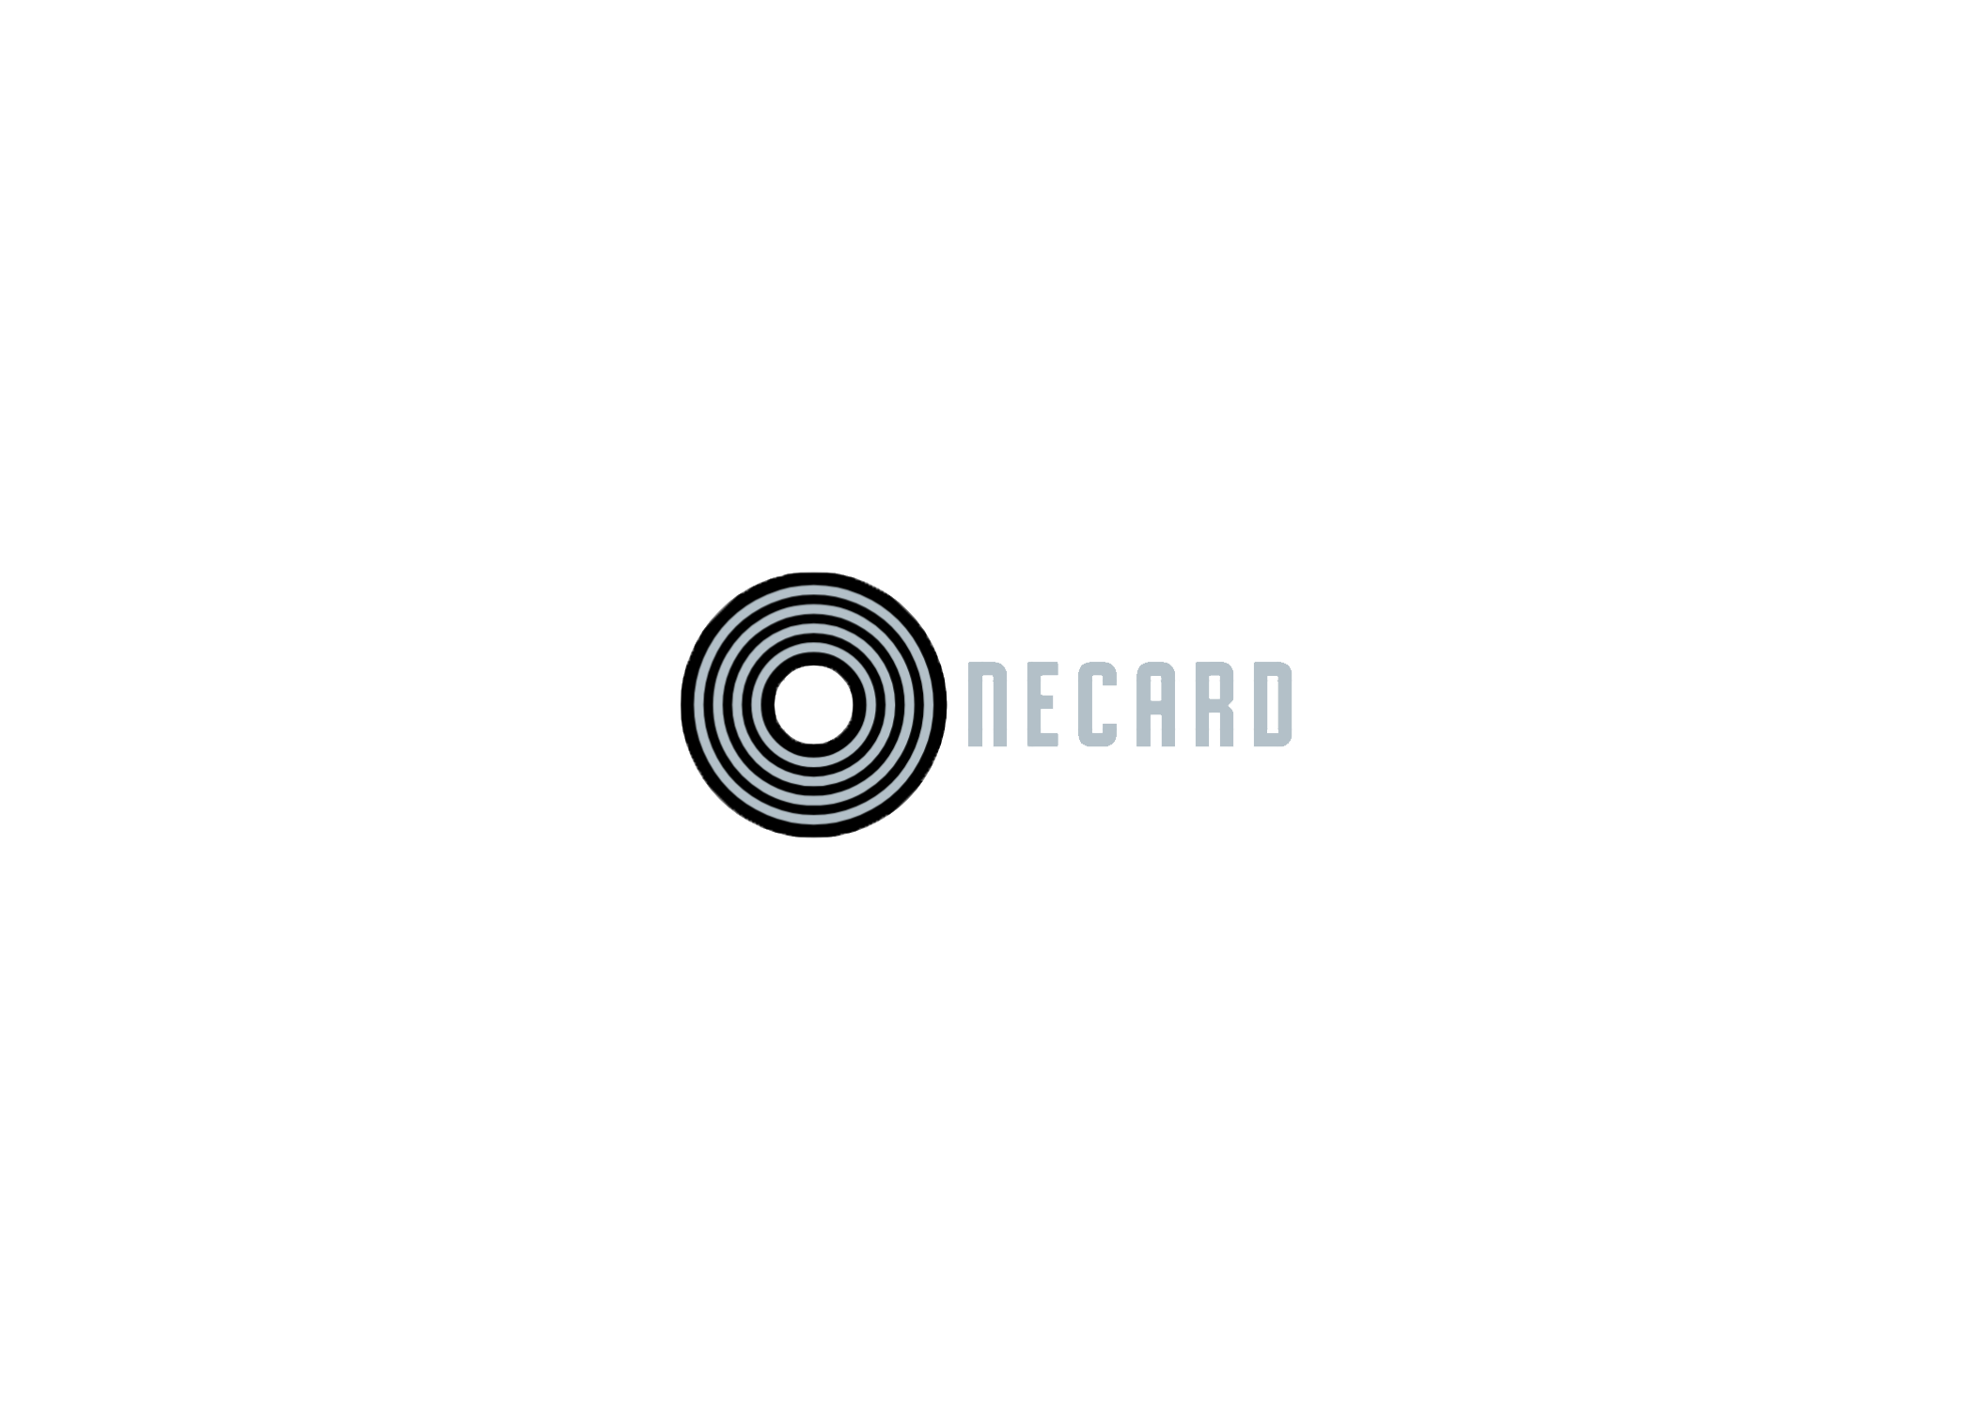

After Alterations:

Please view PDF for step-by-step details on how to operate machine